DATA SPLIT AND CROSS VALIDATION

AIM:
To implement a K-Nearest Neighbors (KNN) classification algorithm to predict student results based on hours studied, attendance, and assignments, and evaluate the model using 5-fold cross-validation.
ALGORITHM:
- Import the required Python libraries.
- Load the dataset from the CSV file.
- Select Hours_Studied, Attendance, and Assignments as input features and Result as the target.
- Split the dataset into 80% training data and 20% testing data.
- Create a KNN classifier with $K=3$.
- Perform 5-fold cross-validation on the training data.
- Calculate and display the average cross-validation accuracy.
- Train the model using the training data.
- Predict the results for the test data.
- Calculate and display the test accuracy.
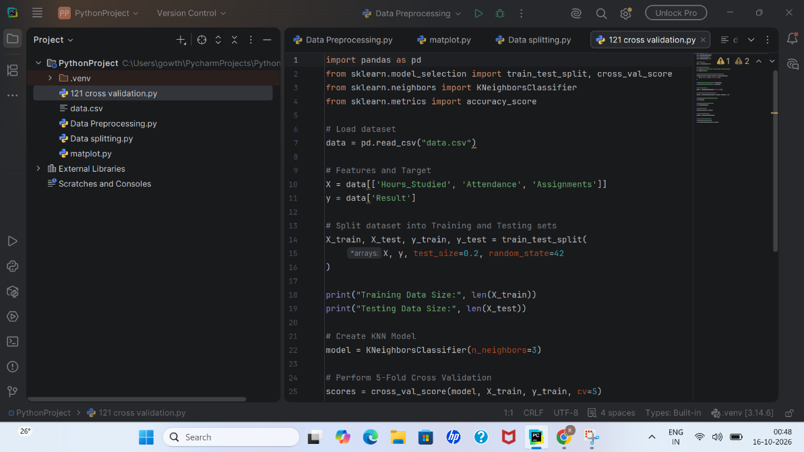
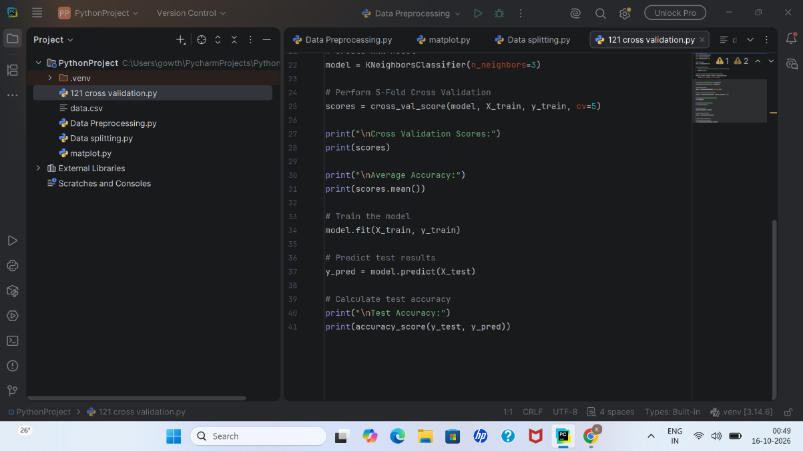
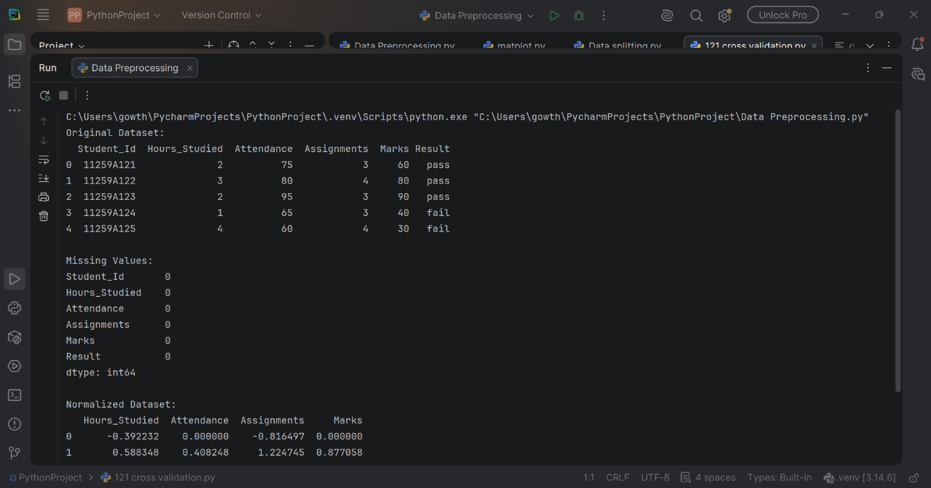
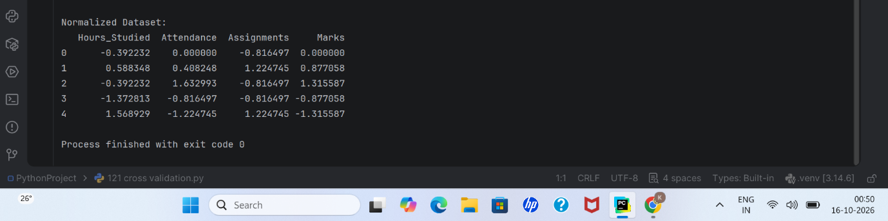

RESULT:
Thus, the K-Nearest Neighbors (KNN) classification algorithm was implemented successfully. The model's performance was evaluated using 5-fold cross-validation and test accuracy.

